Scottish Athletics Field Events Grand Prix Series (Incorporating Hammerama & Seated Throws) 2015

(Held under UKA & IPC Rule – IPC approved)

Venue - Craigswood Stadium Livingston

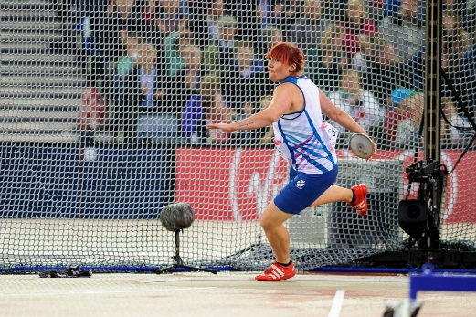
Dates:-
GP1 – 11 & 12 April - 2015
GP2 – 6 & 7 June - 2015
GP3 – 25 & 26 July - 2015

GP Final – 5 & 6 September

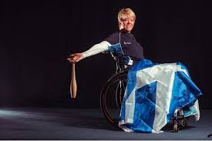

Supporting Field Events in Scotland
Save money by pre-entering

Pre Comp Entries: £5 per event.
On the day £10 per event.
Series Entry: £16 per event (series entry fees will be collected at the first GP Meeting

Entries close 1 week prior to each event
Prizes will be awarded throughout the age groups. Details to be announced later

Entries should be sent to:
Mary Anderson
Scottish Athletics
Caledonia House
South Gyle
Edinburgh
EH12 9DQ

Or e-mail
mary.anderson@scottishathletics.org.uk

Entry Fees will be collected on the day at registration

- Declarations will close 1 hour prior to event.
- Weigh in for personal implements 60 min prior to
Event
- All athletes will get 6 attempts (throws and horizontal jumps)
- 2 Warm up attempts will be allowed

Official Entry Form

Name____________________________________

Club/School_______________________________

Date of Birth_______________ Age Group _____________________

Address ____________________________________________

Email Address______________________

Telephone Number_____________ Mobile Number________________

SAL Membership No ___________________________________

IPC Classification_______________________________________

Favourite music track_________________________________

Event 1 ____________ PB_____________

Anticipated Performance_________

Event 2_____________ PB_______________

Anticipated Performance _______________

Event 3_____________ PB_______________

Anticipated Performance _______________

GP1 – Saturday 11/Sunday 12 April 2015

GP2 – Saturday 6/Sunday 7 June 2015

GP3 – Saturday 25/Sunday 26 July 2015
GP Final – Saturday 5 Sunday 6 September 2015

Provisional Timetable

 |  | Saturday
Event No | Time | Event | Grading
1 | 10.00 | Hammer | Senior/U20 Women
2 | 10.00 | High Jump | Start height 1.30 -1.55m
3 | 11.15 | Hammer | Under 11/13
4 | 11.15 | Javelin | Up to 40m
5 | 12.30 | Hammer | Senior /U20 Men
6 | 12.30 | High Jump | Start height 1.55 - 1.75m
7 | 14.45 | Hammer | U17/15 Girls
8 | 14.45 | Shot | Up to 9m
9 | 16.00 | Hammer | U20 M/W; U17/15 Boys
10 | 16.00 | Shot | Between 9 - 11m
 |  | Sunday
 | Time | Event | Grading
1 | 10.00 | Discus | Up to 25m
2 | 10.00 | Long Jump | Between 4.50 - 5.20m
3 | 11.15 | Seated Throw | Club, followed by discus
4 | 11.15 | Shot | Over 11m
5 | 12.30 | Long Jump | Between 5.20 - 6.00m
6 | 12.30 | Javelin | Over 40m
7 | 14.45 | Long Jump | over 6.00m
8 | 14.45 | Discus | Between 25 - 40m
9 | 16.00 | Hign Jump | Start height 1.75m
10 | 16.00 | Discus | Over 40m
 | Dates | April 11/12 | Events as above
 |  | June 6/7 | Triple Jump instead of Long Jump
 |  | Jul 25/26 | Events as above
 |  | Sept 5/6 | Triple Jump instead of Long Jump

